Case study 4.3: Hands-off FCL using autoISF on Christmas V.3.0

This report shows that also during the Christmas holiday week, with its
typical much stronger carb load and less physical exercise, a completely
hands-off FCL is possible.

The previous report on a 5-day period in 2023 is, further down, complemented with a 1 week report from two years later (2025).

Method (2023)

FCL with (then not yet released) dev variant of AAPS 3.2.0.4 w/autoISF 3.0.1
Lyumjev 100 (DIA 7h) in Combo pump w/ 10mm Teflon cannula (0-48h)
2 x G6 overlapping (see case study 1.5; sensors used ~ d3 – d15; xDrip; no smoothing in AAPS)
profile basal ~ 14 U (0.41…0.75 U/h); profile_ISF 36…44 mg/dl/U (circadian);
TDD 43 U (which is above his normal TDD, see p.2).

Main settings for 24/7 adaptation of ISF *):
- SMB range extention and autoISFmax both = 2.9; SMB delivery ratio = 0.75 fixed
- bgAccel_ISF_weight = 0.24; pp_ISF_weight = 0.03; dura_ISF_weight 0.8
- iobTH_percent=60
*) Caution: Do not copy settings from others,
not even for starting your tuning.
Why, see FCL e-book section 4.1.

No user interference:
- no boli
- no carb inputs
- no setting Eating Soon
- no “manual nudging” via the top fields in AAPS main screen (%profile, exercise, TT).

Loop did use the following Automations (from the initial FCL set-up, as described in FCL e-book):
- For meal management: Automation that sets TT=74 mg/dl for 26m if delta>10 (FCL e-book section 2.5)
- For nighttime management “Adjunct Automations.” (discussed in FCL e-book section 5.1.2):
  - Operate with an odd profile target at 3am-10am for default SMB shut-off…
  - …complemented by Automations to get temp. SMBs (if bg>160; iob<3.5) during nighttime
  - Note: If tester normally would do breakfasts, set odd profile TT would end earlier than 10 am
- Activity monitor 24/7 on. Scale factors 1.2 activity and 0.3 inactivity.

Result (2023): 96% TIR (HbA1c ~ 5.6%) during 5 days at Christmas

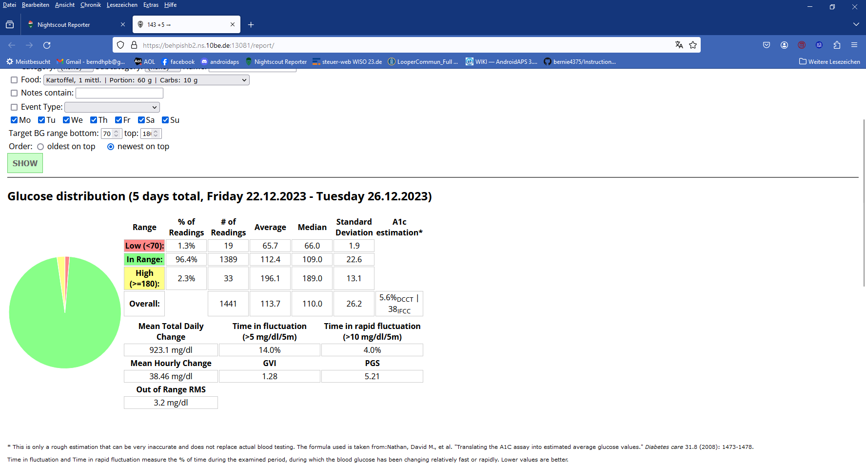

Negligable hypo tendency

The statistics for the “Low < 70 mg/dl” line of above table shows:
- Only 1.3 % of values were below 70 mg/dl
- Half of those (0.7%) were under the group-median of 66 mg/dl
- Virtually no data point below 62 mg/dl (= Median low minus 2 SD)(61 was lowest in Daily stats)
The percentile report shows, that briefly after midnight the low tendency is biggest (down regulation from dinner coincides with a last dogwalk):
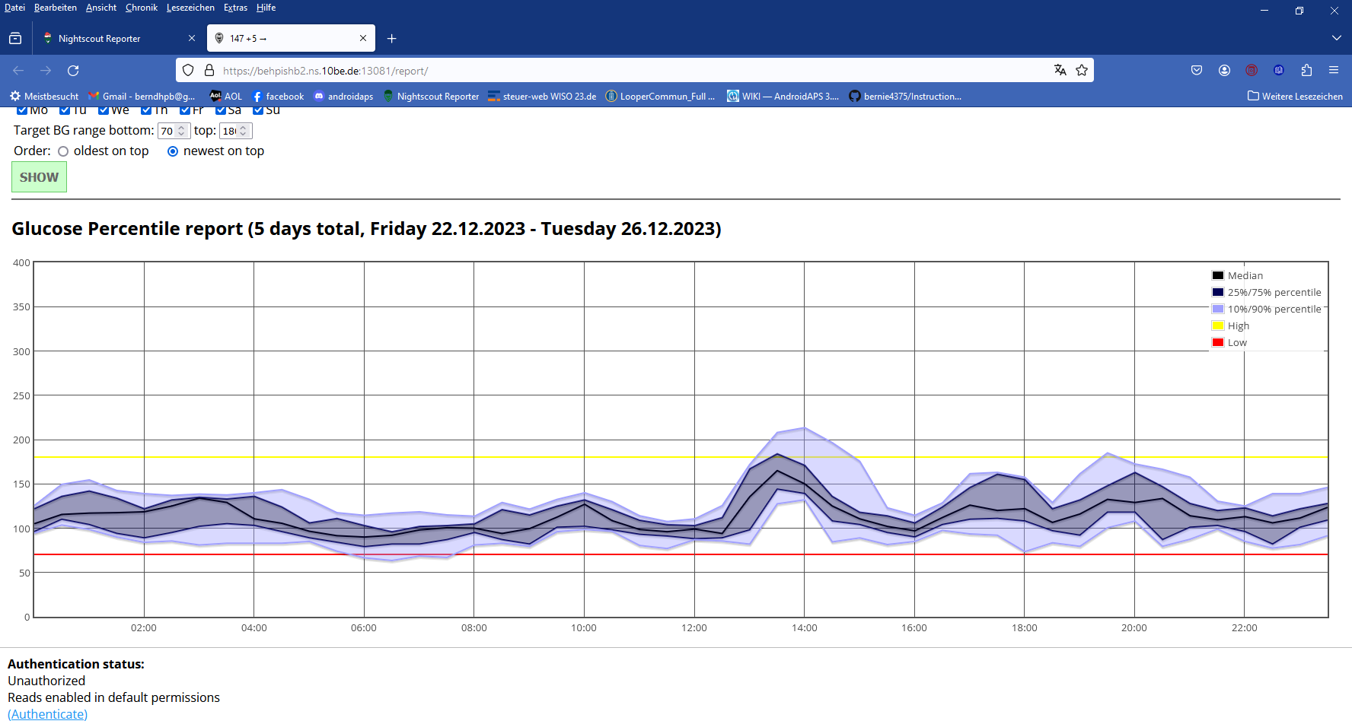

Details for each of the 5 included days:

Due to some excessive eating, TDD was on average 42.8 U (+16% to normal TDD averaging 37U). No big breakfasts. Dinners came relatively late; and once, on Dec 25/26th, there was midnight chocolate fondue w/ 2 gl. sweet hot wine (Glühwein)
Two very big holiday lunches (25th and 26th), goose resp. turkey, with dumplings, vegetables and small desserts; Christmas cookies. No settings were adjusted.
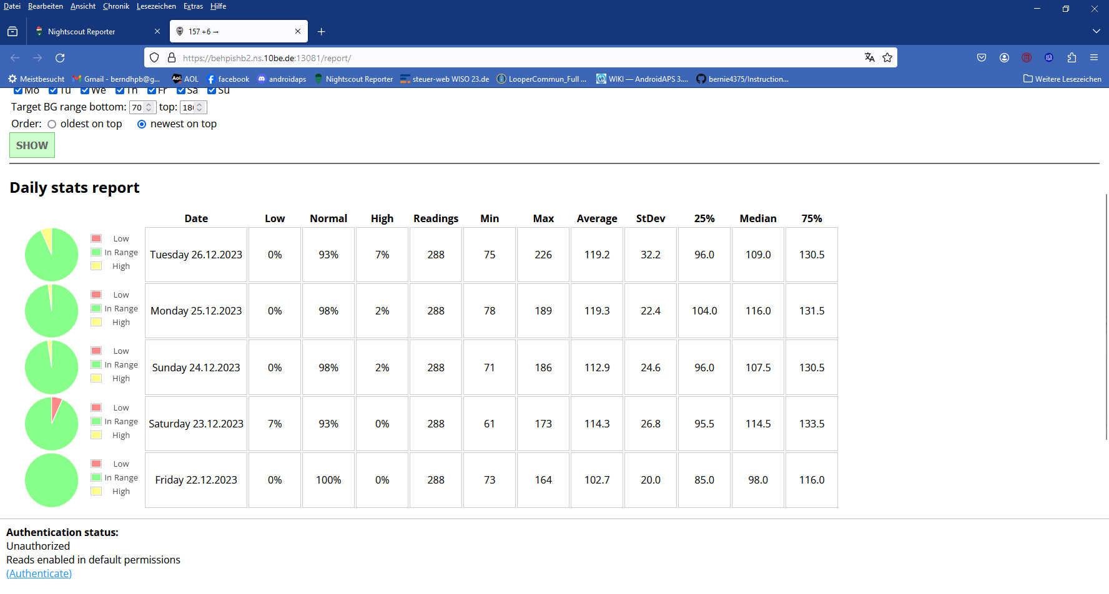

In the daily charts that follow, the SMB sizes are indicated (no bolus was ever given).
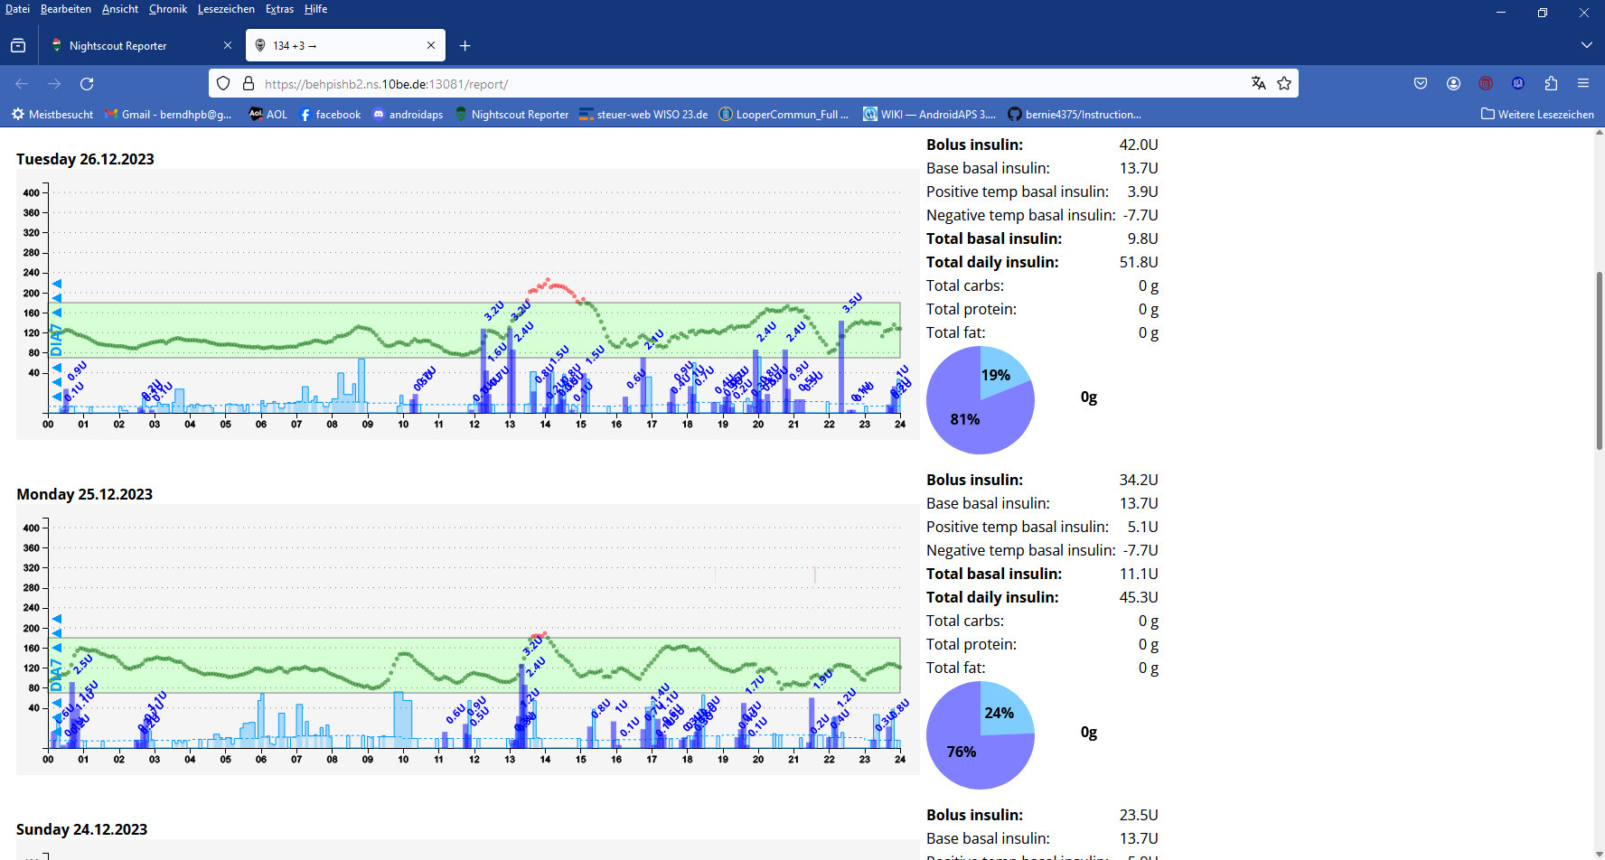
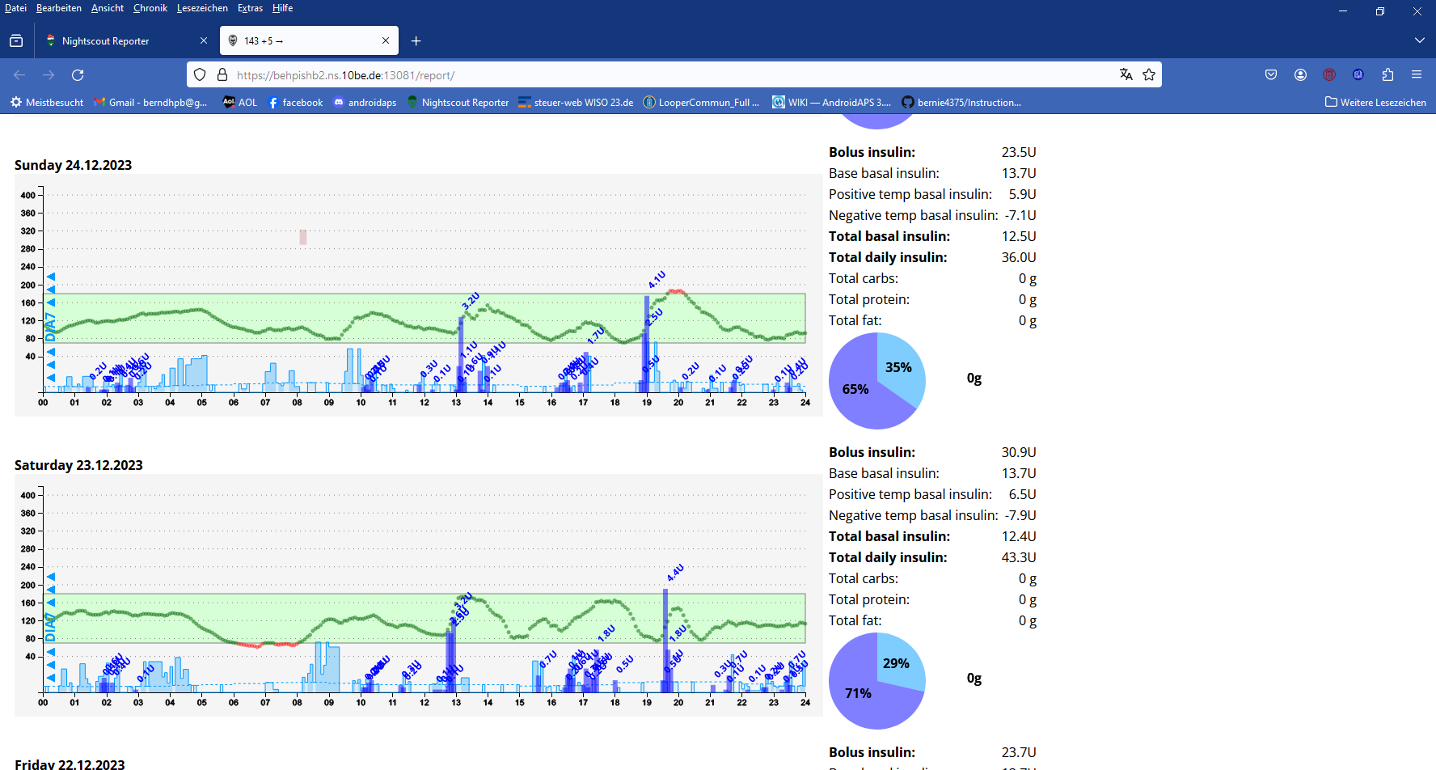

Friday 22.12.2023 …
…was a 100% TIR day (chart not included)

Method (2025) nearly unchanged from 2023

FCL with AAPS 3.3.3.a + autoISF 3.1.0
Lyumjev 100 (DIA 8.5h) in Combo pump w/ 10mm Teflon cannula (0-48h)
2 x G6 overlapping; no smoothing in AAPS
profile basal ~ 14 U (0.41…0.75 U/h); profile_ISF 36…44 mg/dl/U (circadian);
TDD 45 U (which is ~20% above the avg TDD).

Main settings for 24/7 adaptation of ISF *):
- SMB range extention and autoISFmax both = 2.9; SMB delivery ratio = 0.75 fixed
- bgAccel_ISF_weight = 0.22; pp_ISF_weight = 0.03; dura_ISF_weight 0.7
- iobTH_percent=60
*) Caution: Do not copy settings from others,
not even for starting your tuning.
Why, see FCL e-book section 4.1.

No user interference:
- no boli
- no carb inputs
- no setting Eating Soon
- no “manual nudging” via the top fields in AAPS main screen (%profile, exercise, TT).
A few times, switching between even and odd numbered target was done in the context of snacking (… so taking a Christmas cookie or two won’t receive a “meal started” response by the FCL)

Loop did use the following Automations (from the initial FCL set-up, as described in FCL e-book):
- For meal management: Automation that sets TT=74 mg/dl for 26m if delta>10 (FCL e-book section 2.5)
- For nighttime management “Adjunct Automations.” (discussed in FCL e-book section 5.1.2):
  - Operate with an odd profile target at 3am-10am for default SMB shut-off…
  - …complemented by Automations to get temp. SMBs (if bg>160; iob<3.5) during nighttime
  - Note: If tester normally would do breakfasts, set odd profile TT would end earlier than 10 am
- Activity monitor 24/7 on. Scale factors 1.2 activity and 0.3 inactivity.
Result (2025): 95% TIR (HbA1c ~ 5.7%) during 7 days around Christmas . (very comparable to the 2023 result reported above)

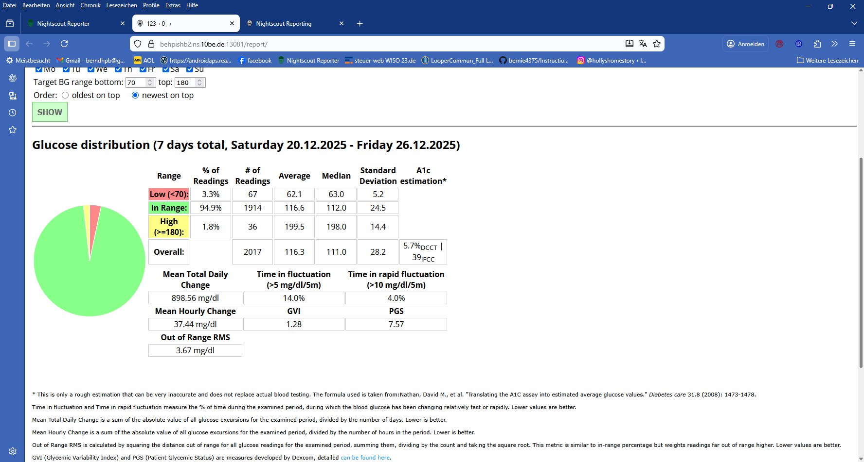

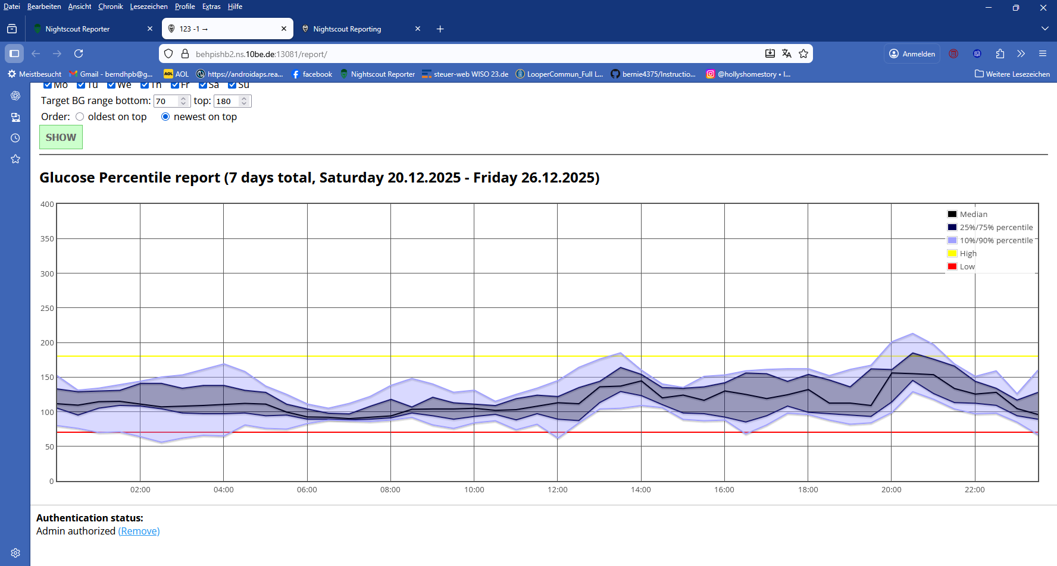
The holiday (Dec 25th, 2025 with big American-style Turkey “dinner” for late lunch) went particularly well:
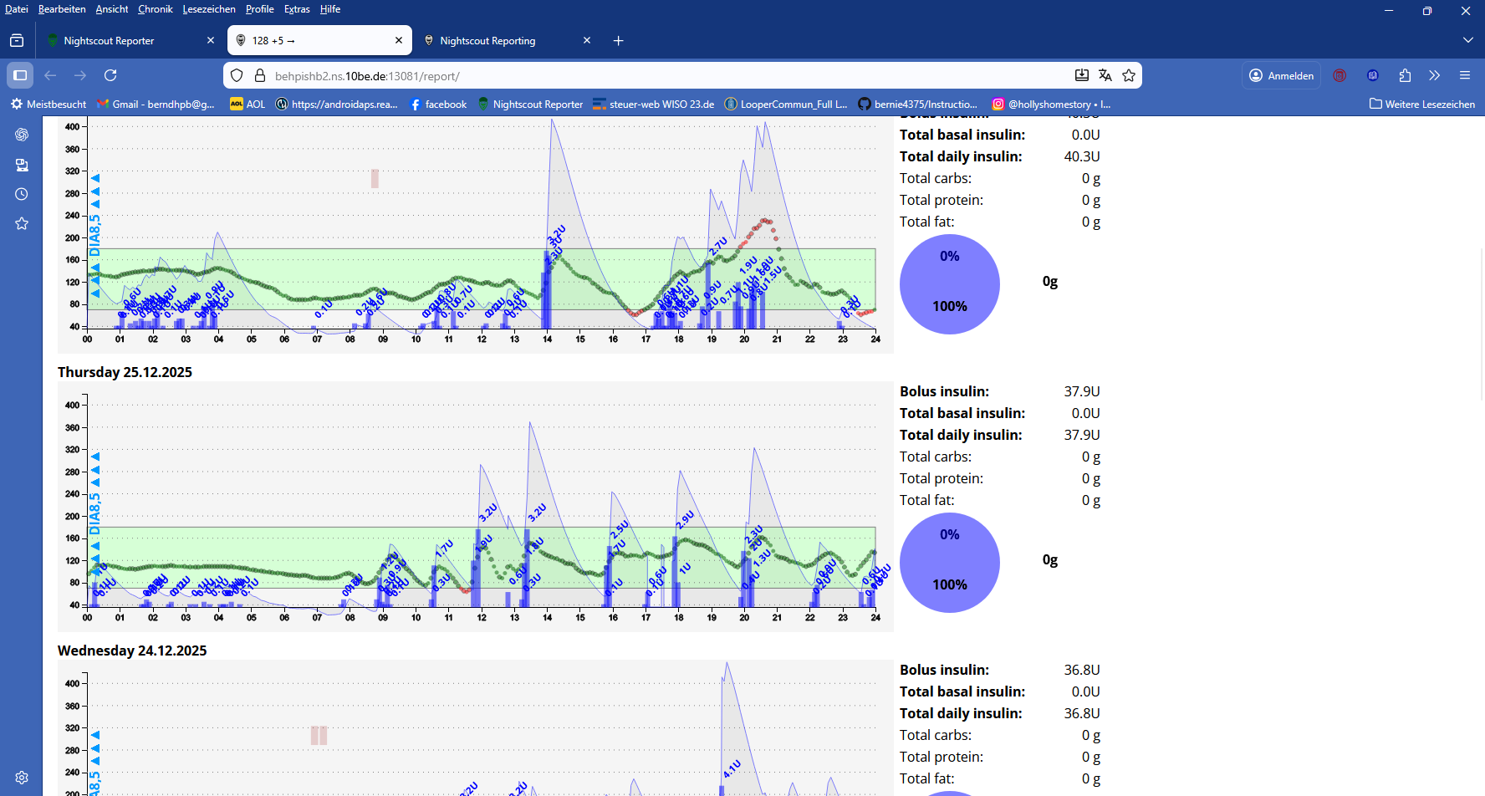

Conclusions

A completely hands-off FCL worked quite well also on days that were characterized by above-average food consumption, and no major exercise.
Going ~ 20% higher in carb intake was no problem for the sophisticated way autoISF auto-adapts to the predicted further glucose curves.
The new “Activity monitor” seemed sufficient to deal with automatic adjustments to frequent inactivity, as well as to several 30-45 minute daily dogwalks.

Moreover, the user was able to operate essentially with the same settings over a two year period.

In the data from 2025 we see a further improved performance with less scatter when starting into the day, and also around and after lunch (see the two 24 h scatter graphs given above).
However, the time after dinner, and in the early night (around 02 h), looked a bit better 2 years earlier, and this warrants a more detailed look:

Discussion regarding FCL limitations

Late heavy dinners and nightly hypo tendency
The 2025 data seem burdened by a day with a dinner high followed by a nightly low.
Tuesday Dec 23 (2025) was the day with too many low values.
The glucose chart reveals that the problem lay exclusively in the very early morning, probably from an over-regulation in the night before:
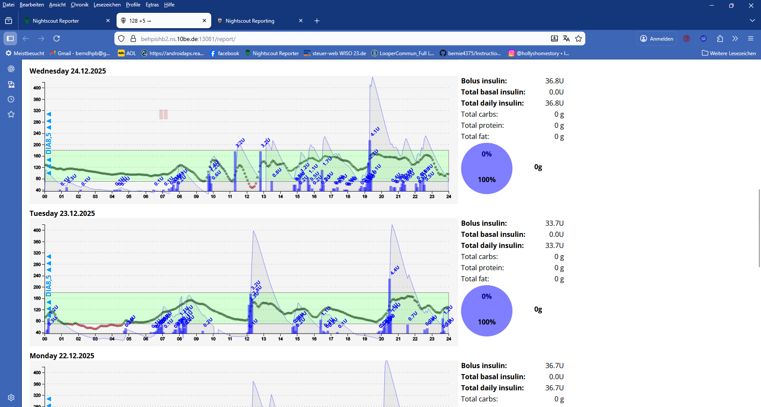
Here a picture for the entire night:

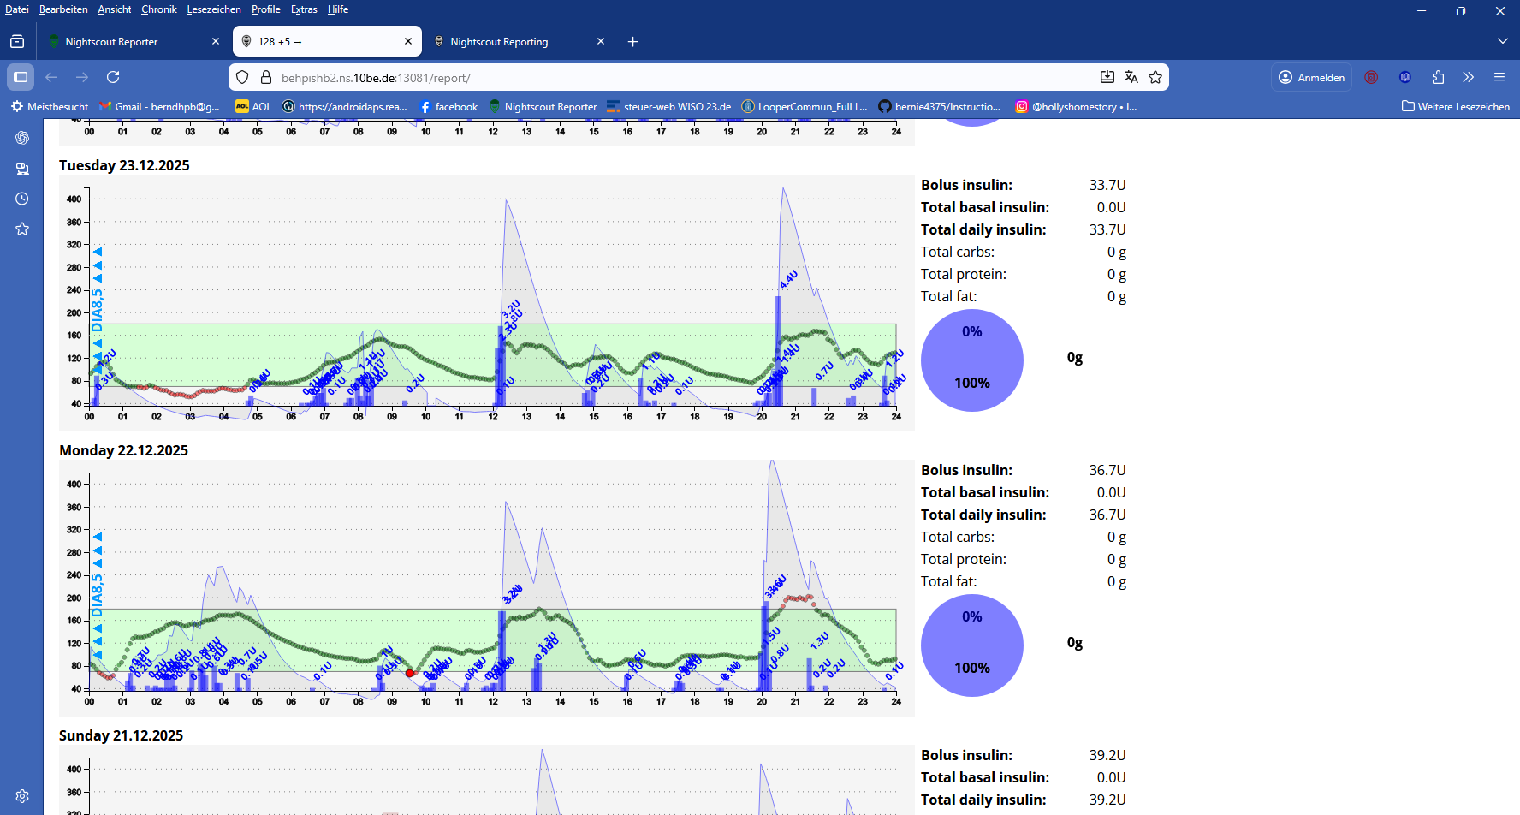

It highlights a potential problem in FCL with heavy late dinners:
By bedtime (around 23:30 h) things looked fairly well balanced out.
However, in the picture we see glucose rising again around midnight, probably from some fat/protein units coming into digestion. Now it is essential that the FCL will not misinterpret this as a full meal start, and respond with lots of insulin.
My standard precaution is to exclude delivery of more SMBs in my sleep times by setting an un-even (odd) numbered glucose target. However, around midnight I still operate with even (98 mg/dl) profile target, and only later my profile goes to the “safer” 97 mg/dl target.
As FPUs sometimes hit even later, and drive bg up in the middle of the night, I have also Automations on bord that allow briefly a few SMBs, then. (This was not needed in the night reported here; for more details on this other scenario see section 5.1.2 in FCL e-book).

As a “Full Closed Looper”, my bedtime routine is to look at glucose trend, iob and insulin activity trend, and the eating pattern in the last few hours to assess whether:
- any late carbs might be lingering around still => set odd TT (bridging over to my odd profile target for sleeptime), so FCL will not act over-aggressively.
(By help from the above mentioned Automation it could still become aggressive briefly, in case needed).
- too much insulin activity is still coming up => small bedtime snack + setting an odd target
- or (usually), all looks in balance => no action needed.

Any 15+ minute walk can also contribute nicely to a desired glucose-lowering effect … or it can introduce the need for a snack
The snack size should be determined with a look into the insulin activity prediction curve, and an idea what FPUs might still be up for digestion.
As already discussed, an odd bg target must be set for small snacks, so no FCL over-reaction will result.
For big snacks, see Automation suggested in FCL e-Book section 5.2.2.3

My mistake in the given example was a misinterpretation, not to think about potential FPUs still coming to digestion. This led to a - mild, and automatically counter-regulated - hypoglycemia between 02 and 04 h (I slept through it. Note that my recommendation is to set a not-silenced alarm when dipping below a certain number!).
The easiest solution to prevent the described problem would be to set the odd profile target already starting at midnight (which I hesitate to do, because sometimes I eat and go to sleep quite late).
As always, it comes down to your personal choice, what suits your lifestyle and your preference regarding tightness of control and (in)convenience.

Snacking
As also emphasized in the FCL e-Book, a snacking habit complicates FCL looping (see e.g. sections 5.1.3 and 5.2.2.3 ).
Holiday situations with plenty cookies, sweet ciders/Glühwein etc around at irregular times, can bring challenges, also to people who usually do not have much of a snacking habit.
Basically, snacks can be accomodated in two ways:
- rather pro-actively, by setting an odd TT if you are in a period of even profile target
- or, by continuing to snack, so the FCL-triggered insulin activity is balanced by more carb absorption over the next hours.
If you are aware of this situation, the latter strategy can actually be nice, munching “mindfully” away on good Christmas cookies etc. However, it resembles the situation when, in HCL you have set a too aggressive ISF (that is what autoISF FCL also does, responding to “false flags” raised by snacks), and face frequent roller-coasters.
Not something you want to have happen frequently. (In extreme case, you would, in a “FCL gone wrong”, replace the puzzle how much insulin to administer with the question, how much more carbs to consume. and gain body weight in the longer term process).

YDMV (your diabetes may vary)
The conclusions that are drawn from this n=1 user experience rely on a well-run initial tuning. Also, the user’s diabetes, general health condition, lifestyle, and, notably, familiarity with the system, suggest he should reach better-than-average results.
Your expectations may vary, too. This study and the FCL e-Book it is connected to, drive for top performance (HbA1c around or under 6%). However, there are lots of fellow patients who would be super well served with a 7 or even 8% HbA1c. We welcome attempts to simplify FCL for this group (see also “Another world” in section 00_Introduction of FCL e-Book).

Keep it simple, and mostly hands-off
Users should resist the temptations to “nudge”, be it with temporary settings or even by sometimes giving a bolus. Any such user action disturbs the workings of the autoISF loop and is – at least on average –unlikely to lead to further improved results.
Actually, we do not have good data on the topic of how exactly pre-boli interfere with a FCL. More discussion see in section 7.3 of FCL e-Book.

What the user should still do, is:
- Look occasionally after BT connectivity (especially after meal starts)
- Look occasionally into the bg and iob (or, better, insulin activity, thin yellow curve) development, and develop some “mindfulness” so to some extent, and only sometimes, this might influence the eating/snacking habit a bit.
- With very special “disturbances” the hands-off FCL runs into limitations.
If snacks are taken in times where the loop is ready for FCL meal response, the user basically has two options:
- “tame” the loop temporarily by setting a odd-numbered TT (top right field on AAPS home screen), or:
- Continue snacking to balance the insulin activity curve resulting from the FCL response to the first rise
Notably if the need for extra snacks shall be kept low, ahead of exercise it can be essential to take special precautions for limiting iob and to elevate the glucose target (as known from hybrid closed loop). See example in case study 6.2

